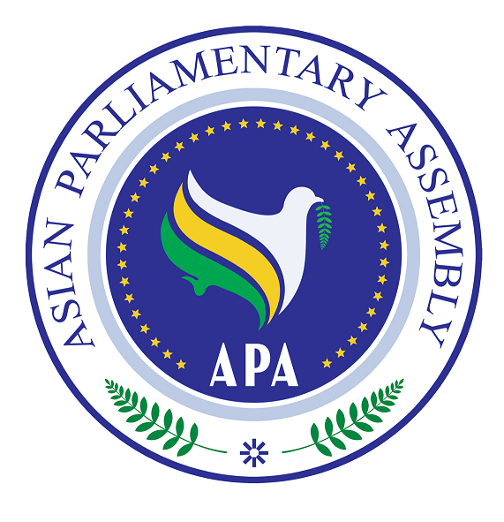  Asian Parliamentary Assembly (APA) | REGISTRATION FORM  Participating in APA Cooperation and Coordination Meeting  At the side of 136th IPU Assembly  10.00-11.00 hours on Sunday, 2 April 2017.  Media Bazar, on the ground floor of the BICC  (venue of the 136th IPU Assembly)

Please fill in Capital Letters, one form for each individual participating delegate and return to APA Secretariat by 26 March 2017.
- Delegation of: …………

- Title (please check Mr. Ms. Dr., etc.)
- First Name:
- Last Name:

- Position, in the parliament
- ……………………………………………………………………………………

- Phone No. | - …………………..……………………………………………..  - Country Code - City Code - Number
- Mobile No.  - Fax No. | - …………………………………………………………………  - ………………………………………………………………..
- Email Address: | - ……………….……………………………………………..

Any Proposal on Emergency Item:

Please return to APA Secretariat:
Email : secretariat@asianparliament.org
Fax: 009821 - 26118809

